## **Hands-On Activity: Creating your first Tableau dashboard**

**TOTAL POINTS 1**

1.

Question 1



## Activity overview



Now, you’ll put together everything you’ve learned about Tableau to create your first Dashboard.

In previous lessons, you did the hard work of connecting to data sources and creating data visualizations. Now, you’ll cap off the process of data visualization by adding them to a dashboard.

Note: You will need the Tableau Public Desktop app to import the Dashboards Starter Template in this activity. For more information on downloading the Tableau Public app, see the [Reading: Optional: Using Tableau Desktop](https://www.coursera.org/learn/visualize-data/supplement/bMjvq/optional-using-tableau-desktop). If you are unable to download the app to your device, use the two visualizations you created in the last Tableau activities as Sheet 1 and Sheet 2 of this activity.



### What you will need

A starter template with a few existing data sources and visualizations and a data set have been provided. Click the link to the folder containing the starter template and data set.

If you are logged into your Google Account:

Click and drag to highlight both the template and the data set. Then, right-click on the selected files and click Download.

If you are not logged into your Google Account:

To download both items, click the DOWNLOAD ALL button in the top right corner of the page. You do not need a Google account to download the files.

Download the starter template and data set: [Starter template and data set](https://drive.google.com/drive/folders/12Ajyz_h6C4TW5CJfwq70KCMwl0rVT-8U)



### Getting started



In a business context, data visualizations are most useful when they are presented in a dashboard-style format to stakeholders. Dashboards put all the pertinent information in the same place, making it easier to understand the important takeaways. Many dashboards are also constantly updating to reflect new data, and some are even interactive! No matter what style you choose, dashboards are a way of actually delivering the work you’ve done when creating visualizations.

Now it's time to begin the activity. Once you have downloaded the Dashboards Starter Template, find the file in your storage and open it in Tableau Public Desktop.

Upon opening the Tableau project template, your screen should look like this:

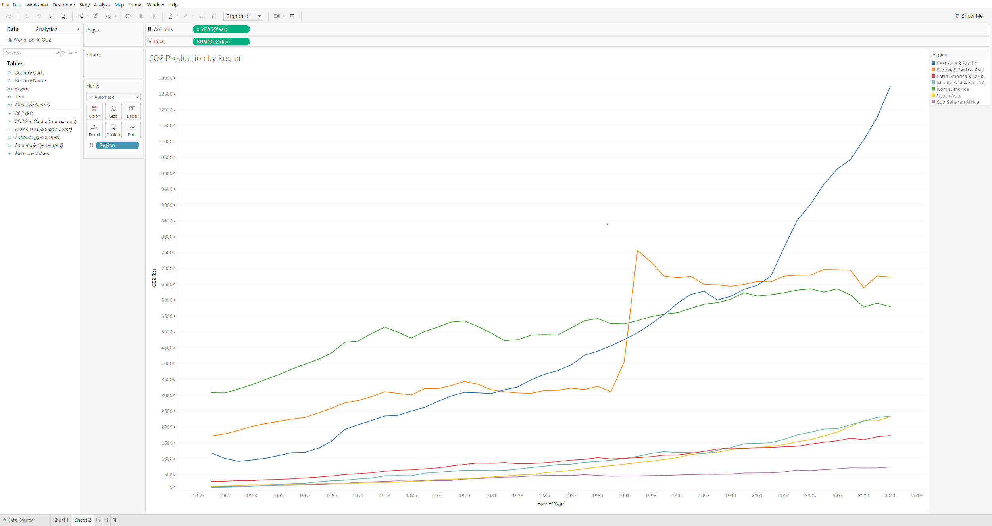

there are multiple multi-colored lines each representing different data

The starter template workbook you downloaded should allow you to see and manipulate the visualizations found in two sheets, Sheet 1 and Sheet 2. However, the Tableau workbook does not contain the actual data set.

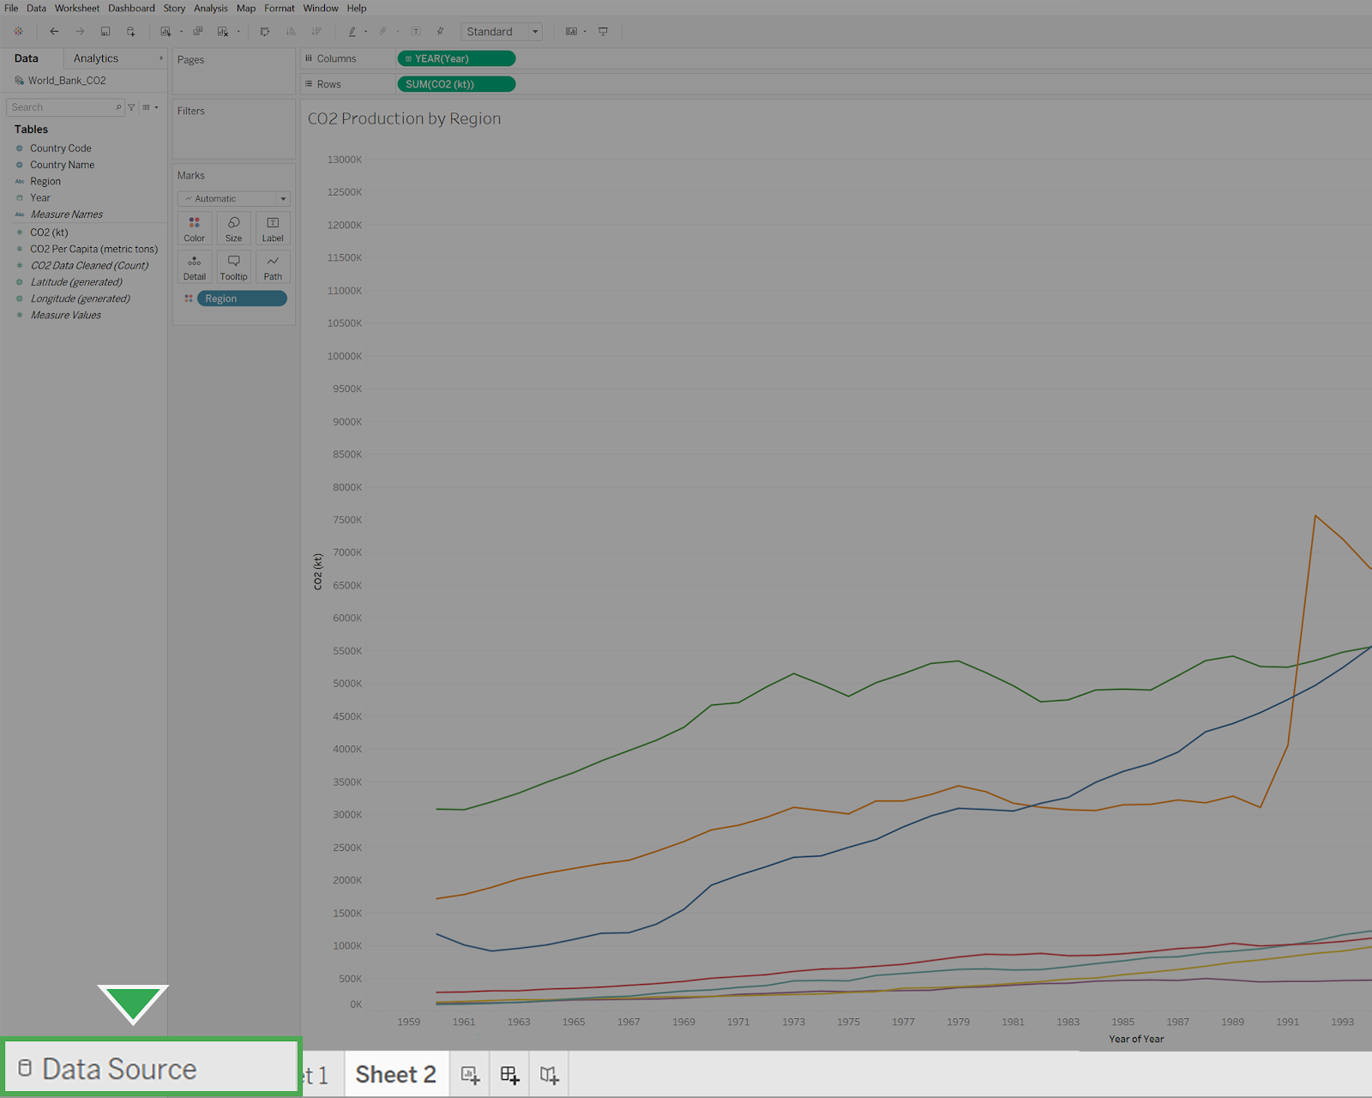

To load the actual data set:

1. Click the Data Source tab in the bottom left-hand corner of the window. This will open the Datasources folder Tableau Public has created on your machine by default.
2. To connect to the World Bank CO2 data set, navigate to the location on your computer where you downloaded the data set.
3. Select World Bank CO2.

As a best practice, you should move your data set for Tableau into the Datasources folder. To do this, locate where the My Tableau Repository folder was created on your system.

4. Double-click the folder My Tableau Repository.

5. Double-click the folder Datasources.

6. Drag your data sets for Tableau from where you downloaded them into the Datasources folder.

This will help you keep track of your data sets for various projects and stay organized.

### Step 1: Creating a dashboard



The example project contains the World Bank CO2 data set, with two separate visualizations. Click Sheet 1. This visualization shows the average CO2 per capita of each country. Now, click Sheet 2. This visualization is a line chart of the CO2 production of each global region over time.

These visualizations will serve for creating a dashboard. To create a dashboard, click the Add Dashboard button, which is the middle button on the bottom row with a symbol that appears like a spreadsheet with a plus sign.

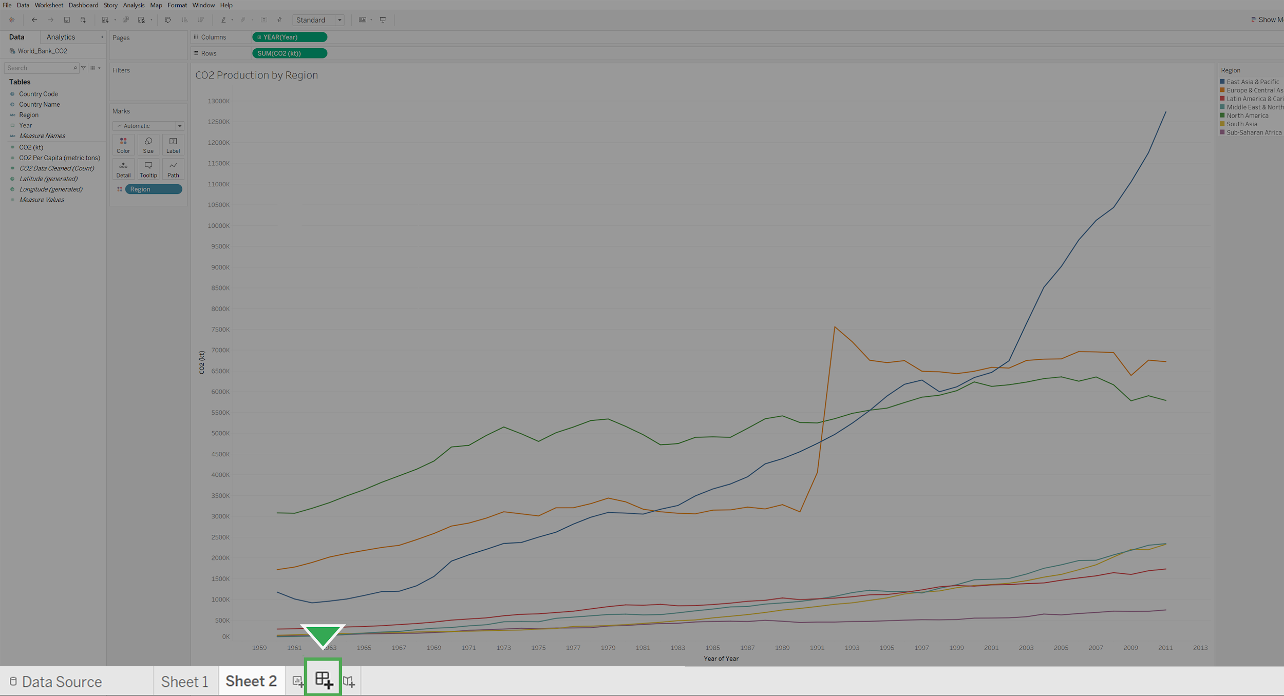

This will open up a new dashboard. Your screen should resemble something like this:

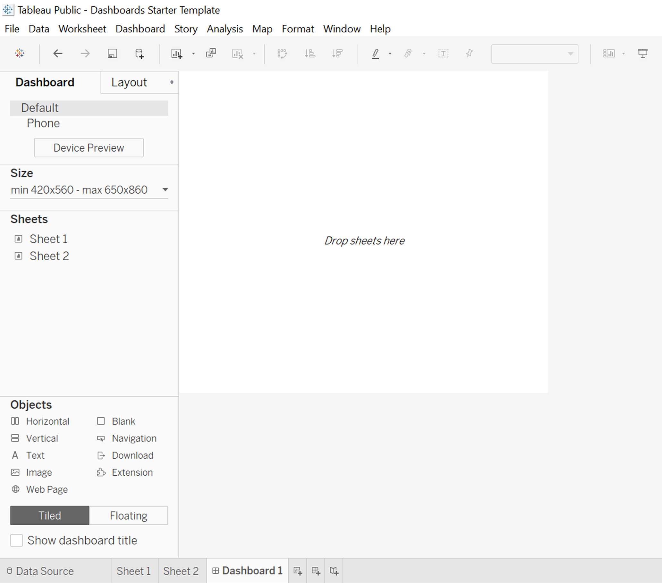

Now, you just need to add some visualizations to your dashboard.

### Step 2: Adding visualizations



To add visualizations to a dashboard, you only need to drag the appropriate sheets onto the dashboard in the layout that you prefer. In this case, we’ll add the map visualization from Sheet 1 on top of the line graph from Sheet 2.

1. Start by finding Sheet 1 in the Sheets section on the left-hand side of the screen. Click and drag Sheet 1 onto the area that says Drop sheets here. Your screen should reflect this:

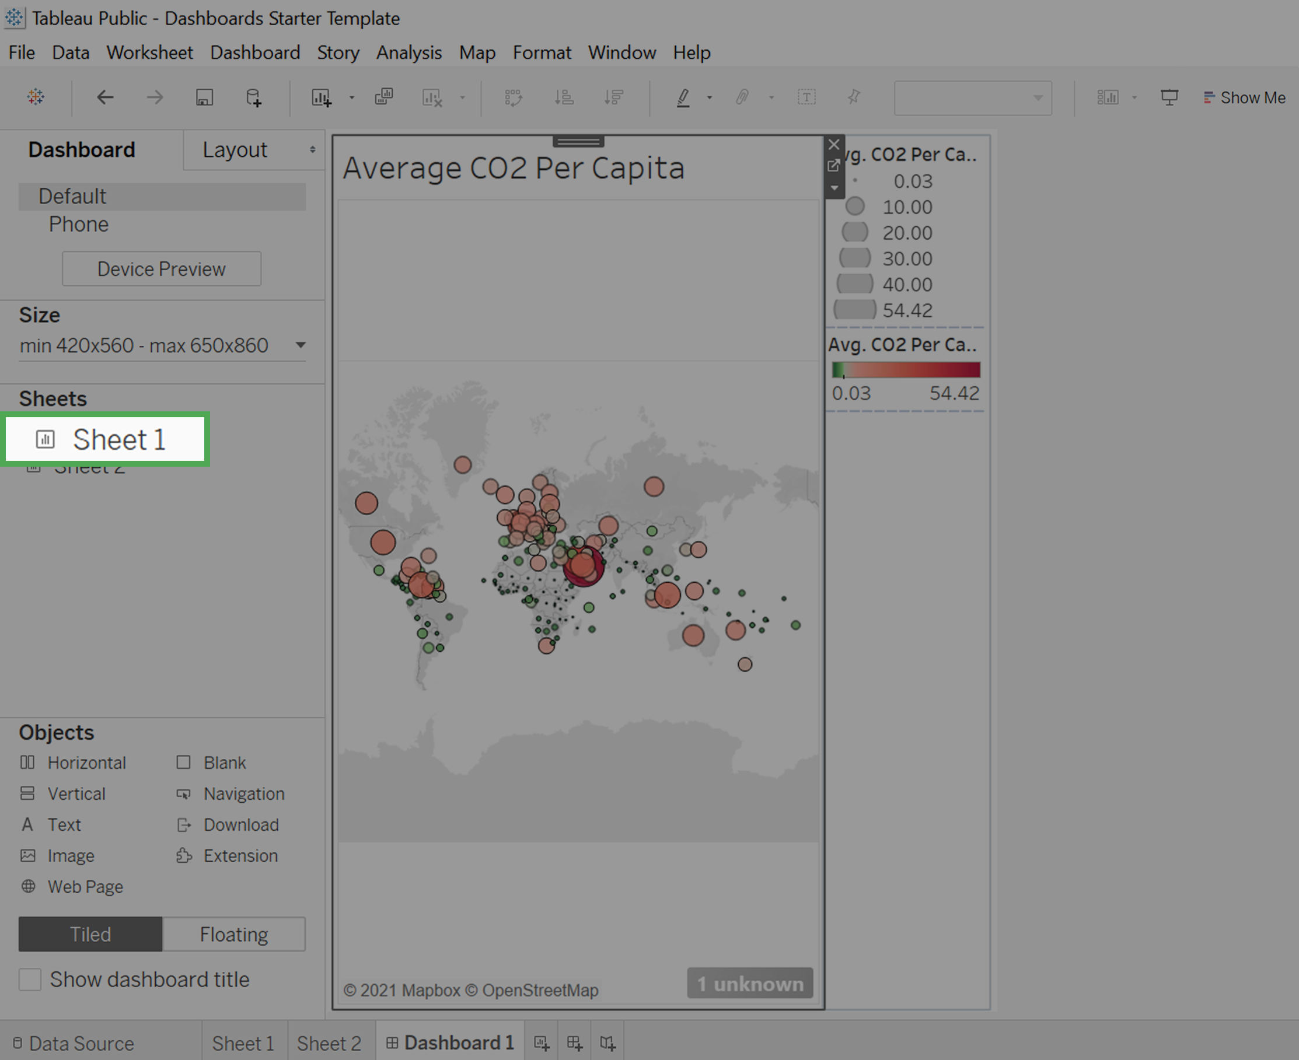

2. Click and drag Sheet 2 onto the visualization. You’ll notice that the visualization adjusts to show the layout depending on where you drag the sheet. Place Sheet 2 so that it takes up the bottom half.

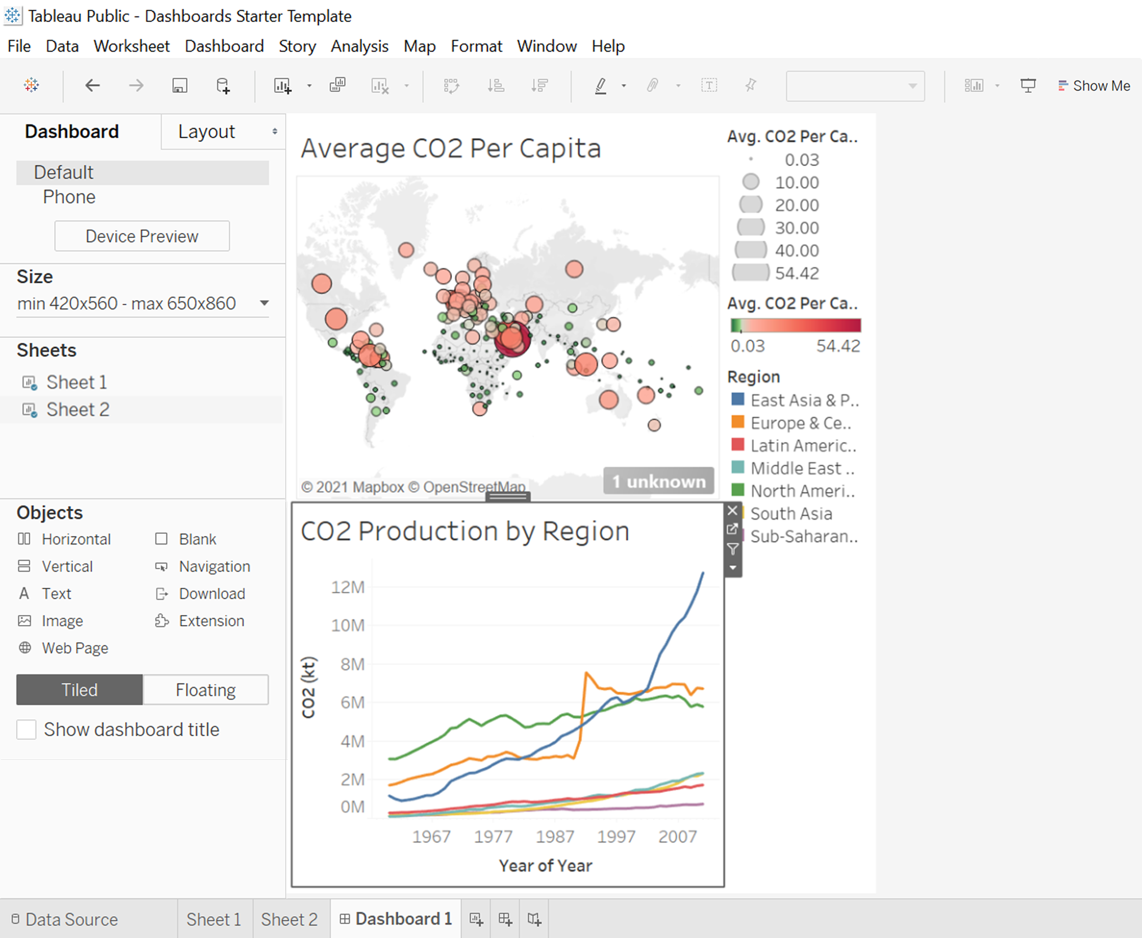

### Step 3: Cleaning up the dashboard



The dashboard currently contains three legends, but only two of them are needed. The topmost legend of grayscale values represents the CO2 Per Capita by size.

CO2 per capita is represented by size and color. As such Tableau creates two legends. To simplify the visualization, your best choice is to delete the topmost legend that corresponds to size.

The relationship between small and large emissions can be interpreted by the relative sizes of the circles. However, the color representing the number of emissions per capita is not interpretable without the legend.

1. Delete the topmost legend. To do this, click it and then click the X attached to it to remove it from the dashboard.

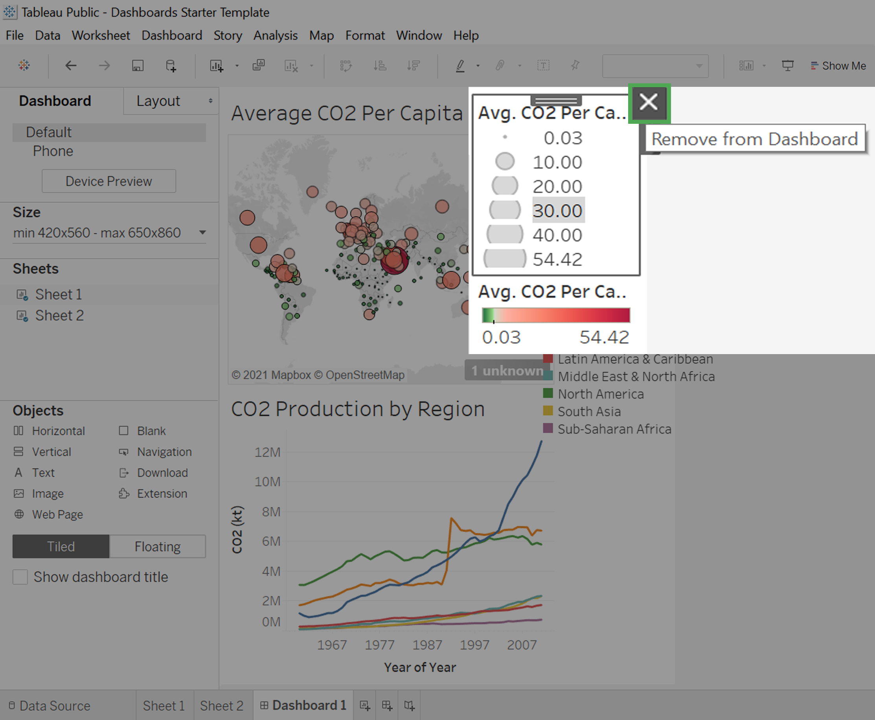

Now that it’s been removed, you’ll set the remaining legends to float.

2. Click on a legend.

3. Click the arrow pointing downwards for More Options. From there, select Floating.

4. Drag the legend onto the top-right corner of the map visualization.

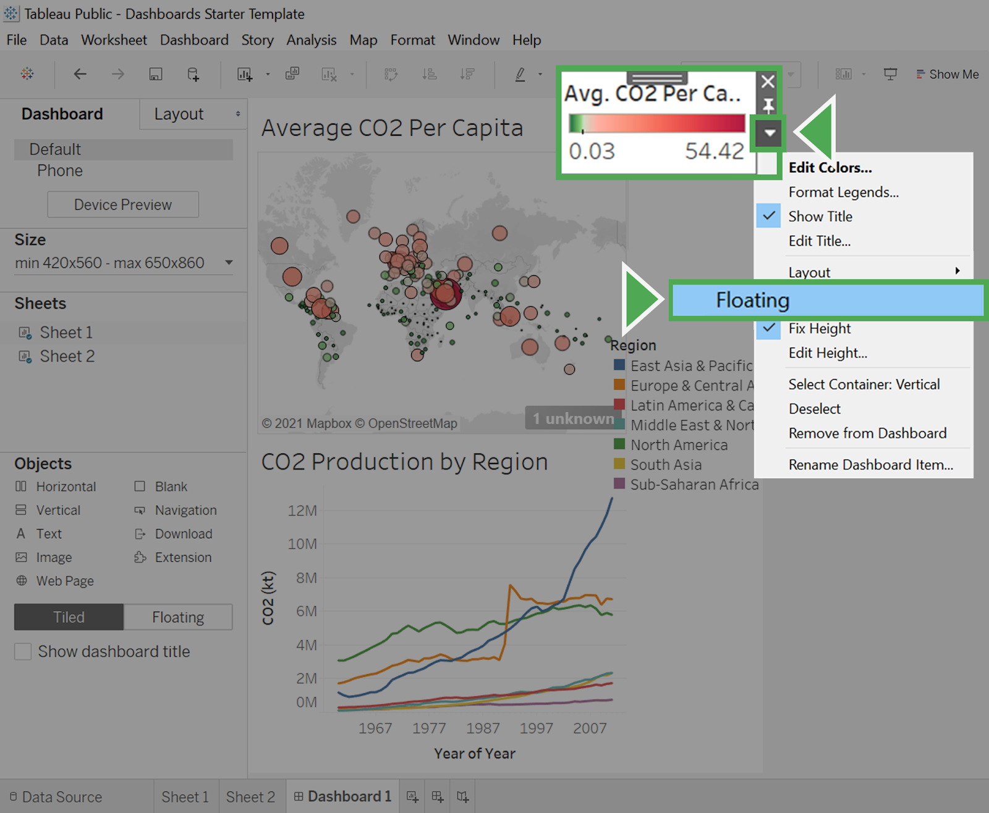

5. Repeat steps 2-4 and float the remaining legend onto the top-right corner of the bottom graph. Once you’ve done it, your dashboard should resemble something like this:

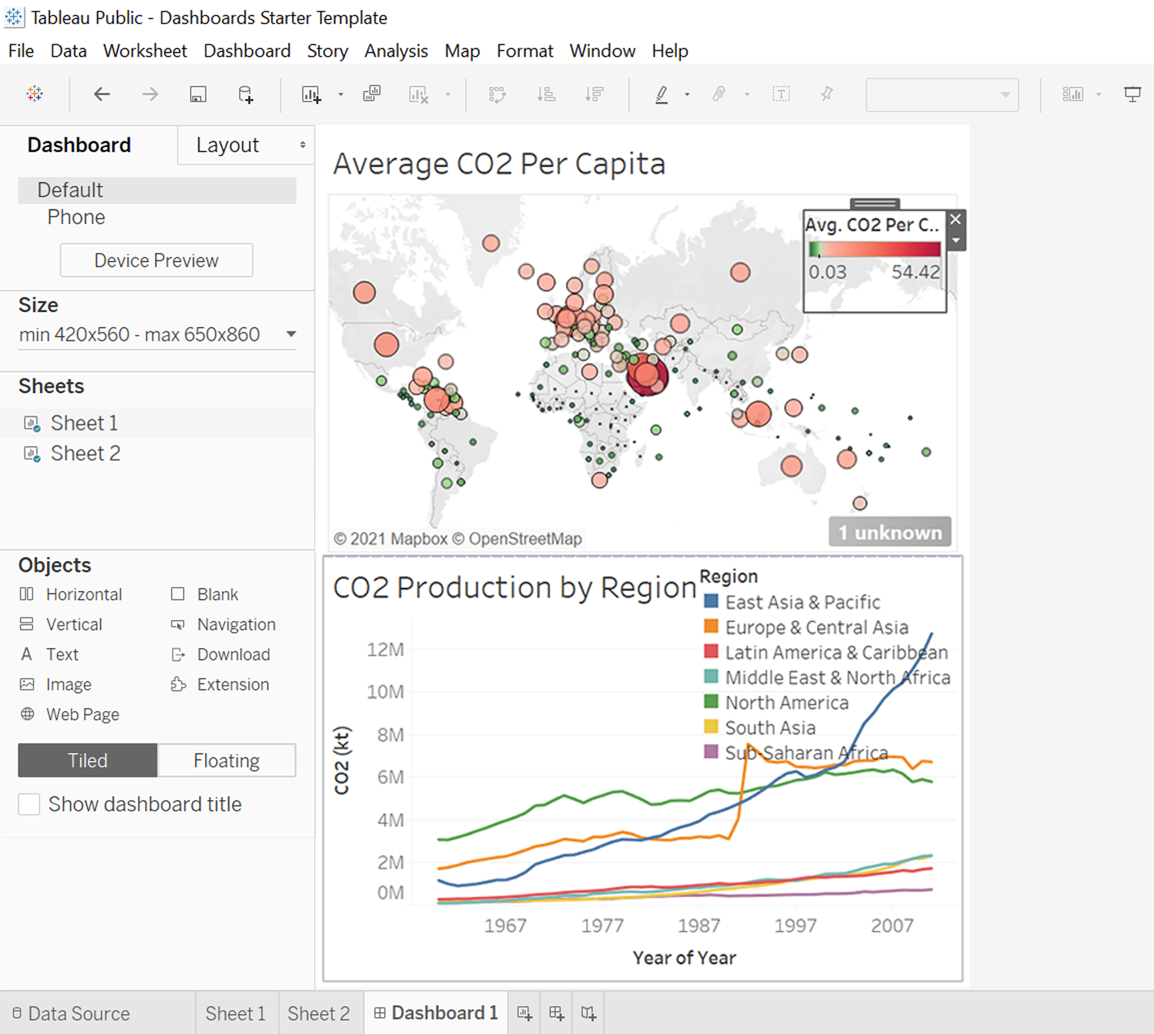

This is much better!

You’ve now created a basic dashboard. Tableau contains tons of other functionality that allows for things like dashboards that update in real-time, or interactive dashboards and visualizations.

Polishing your dashboards is important because it makes it easier for your viewer to understand the information that you are trying to communicate.

Some best practices are, when appropriate, using the same color schemes, and simplifying your visualizations by getting rid of redundant information.

## Reflection



In this activity, you created a dashboard that can help you share your findings. In the text box below, write 2-3 sentences (40-60 words) in response to each of the following questions:

* What are some other ways in which you might use dashboards?
* In future projects, is there a dashboard that you would like to create? If so, what kinds of data might it feature?

**Correct**

Congratulations on completing this hands-on activity! A good response would include how the ability to build useful dashboards is a very valuable skill for data analysts to have at any stage of their career.

A data analyst’s effectiveness is strongly dependent on their ability to communicate their findings to stakeholders. Dashboards are an accessible and thorough way of communicating by telling stories with data visualizations.